**Monitoring**

**Topics: CloudWatch Metrics, Logs, Events, Alarms, EventBridge**

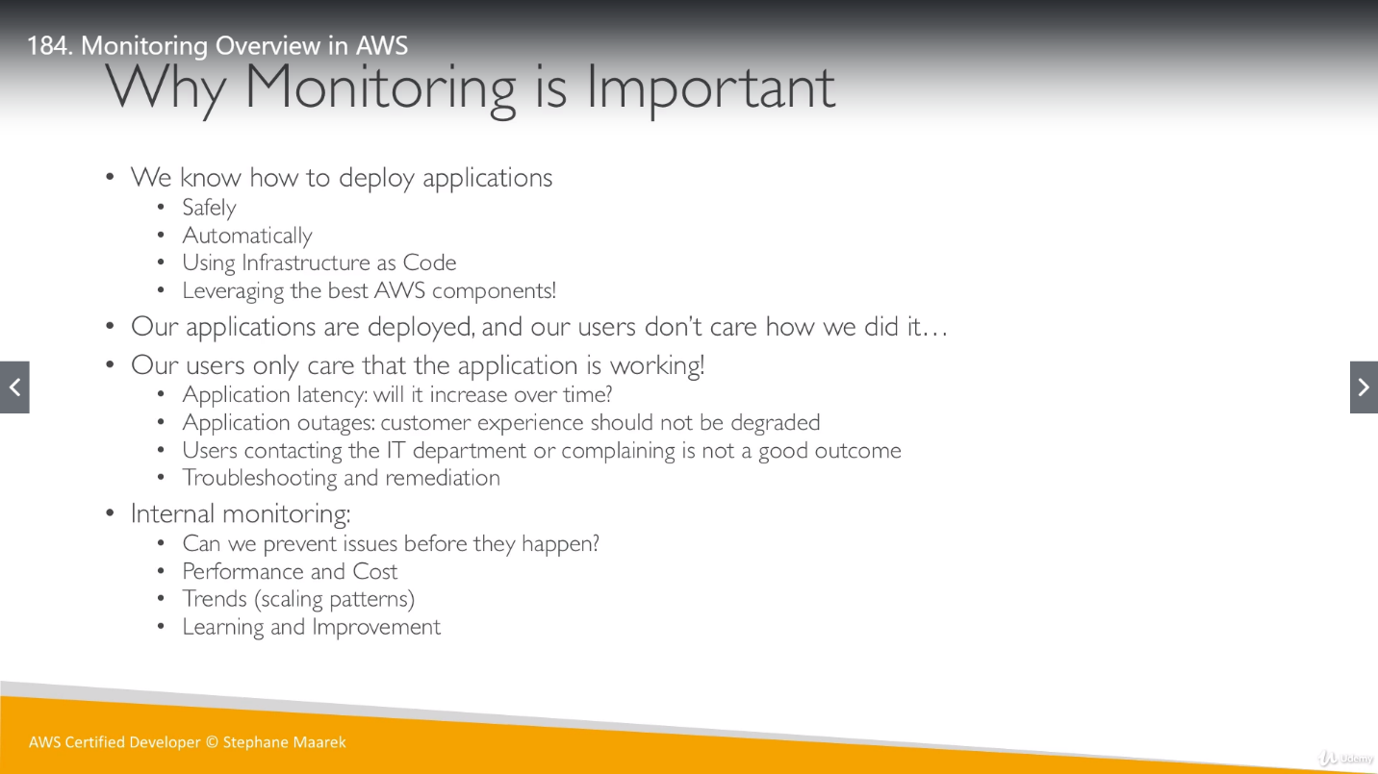

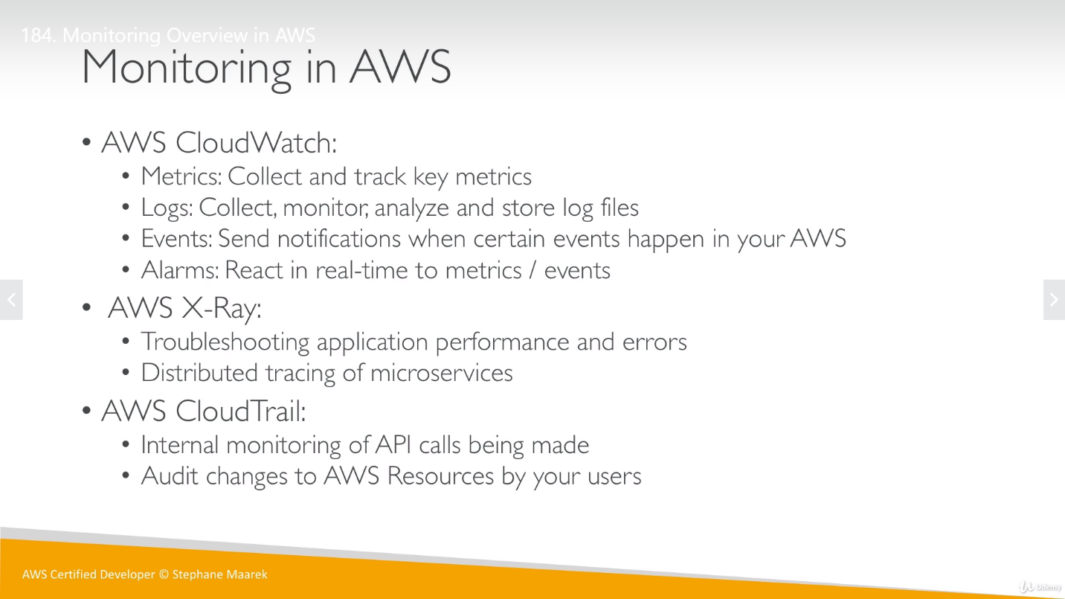

**Amazon CloudWatch:** it is a monitoring and observability service. CloudWatch provide functionality to monitor our applications, respond to system-wide performance changes, optimize resource utilization, and get a unified view of operational health.

CloudWatch collects monitoring and operational data in the form of logs, metrics, and events. CloudWatch provides these logs, metrics and events with a unified view of AWS resources, applications, and services that run on AWS and on-premises servers.

We can use CloudWatch to detect uneven/unusual behavior in our environments, set alarms, visualize logs and metrics side by side, take automated actions, troubleshoot issues, and discover insights to keep our applications running smoothly.

**CloudWatch Metrics: **imp\*\***

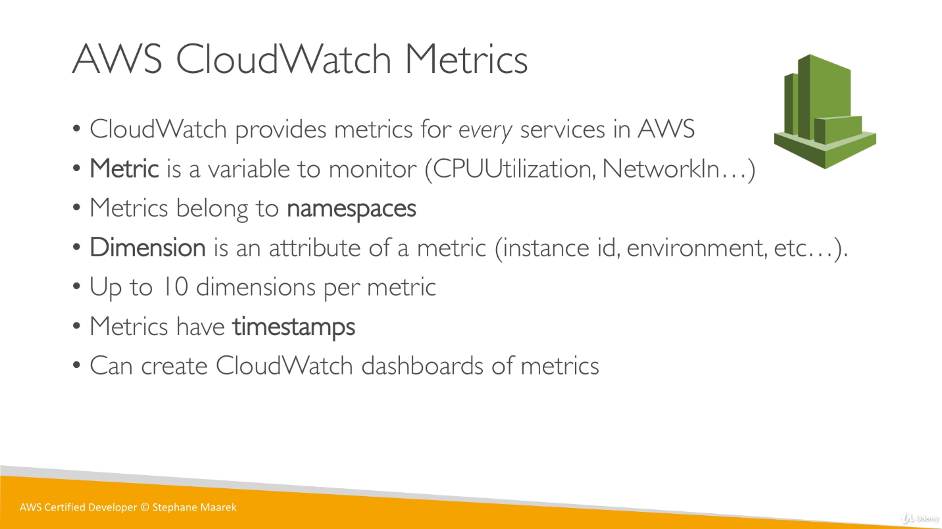

**Namespaces:** A *namespace* is a container for CloudWatch metrics.

Metrics in different namespaces are isolated from each other, so that metrics from different applications are not mistakenly aggregated into the same statistics. We can specify a namespace name when we create a metric. These names must contain valid XML characters and be fewer than 256 characters in length. Possible characters are: alphanumeric characters (0-9A-Za-z), period (.), hyphen (-), underscore (_), forward slash (/), hash (#), and colon (:)

**Dimensions/ Attributes:** A dimension is a name/value pair that is part of the identity of a metric. You can assign up to 10 dimensions to a metric.

Every metric has specific characteristics that describe it, and we can think of dimensions as categories for those characteristics.

**Detailed Monitoring:** We can enable **detailed monitoring** and can change the time of monitoring happening from 5 min to 1 min.

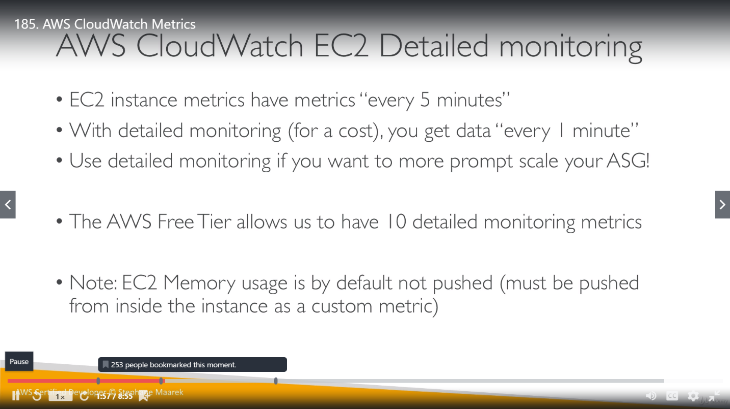

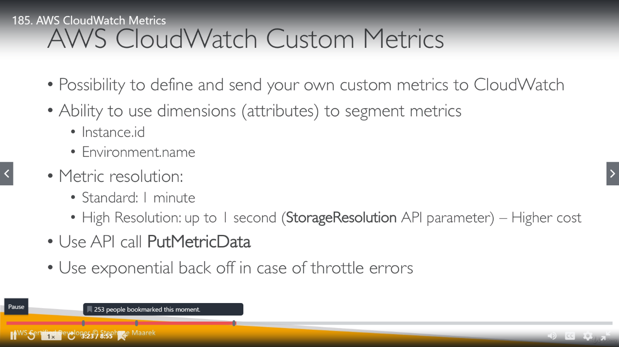

We can save any metric data by creating a Dashboard. We can see these metrics even in services as well. For example, we can open any Auto Scaling Group and check details under monitoring section. Also, we can enable group metrics collections for ASG, as by default it’s not enabled. For basic monitoring we have 5 min minimum period enabled for basic monitoring, but we can minimize it to 1 min using Detailed monitoring.

**\*\*imp\*\*** There is a difference between monitoring time and resolution time. Monitoring time is, in what timestamp the service will be checked per defined metric. On the other hand, resolution time is, on what timestamp metric will be notified for any inappropriate thing. It works for custom metric and alarm both.

**CloudWatch Alarms:**

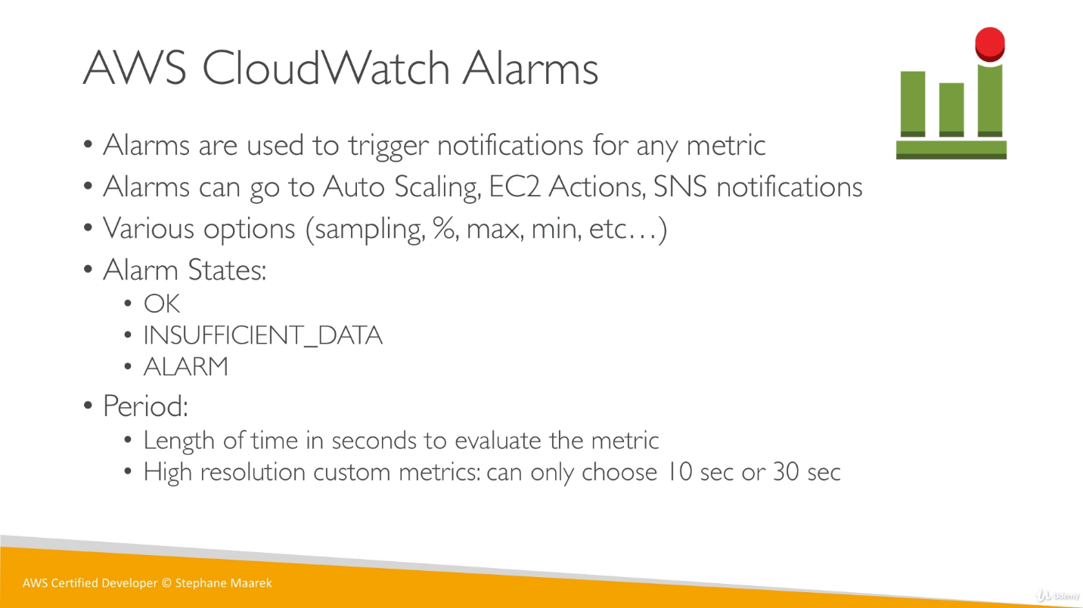

Once alarm threshold is being passed the status will change from OK to ALARM.

Whenever we use Elastic Beanstalk,2 alarms got created automatically for ASG. These alarms are network alarm where first one implies, if network traffic/networkout is less than 2 MB per second for 1 datapoint within 5 min (that mean if ASG have overall traffic less than 2MB per 5 min) then decrease the size of ASG (decrease EC2 instances).

Second one implies that if networkout is more than 6 MB data from 1 datapoint in 5 min then increase or scale up the capacity.

If we see the policy tab of ASG, we can see policies related to CloudWatch monitoring.

So, this will increase/decrease instances once we breach the limit mentioned in these policies. Now we have a clear picture that ASG in increasing/decreasing instances (in the range of Desired capacity-min-max) based on networkout.

Desired capacity tells ASG if per ALARM, we got an indication to remove alarm but maintain at least these many instances, so we saw many times if there is no networkout still we have one instance always because we set desired capacity as 1.

Below SS is for Alarm created for Beanstalk Auto Scaling Group as we defined above.

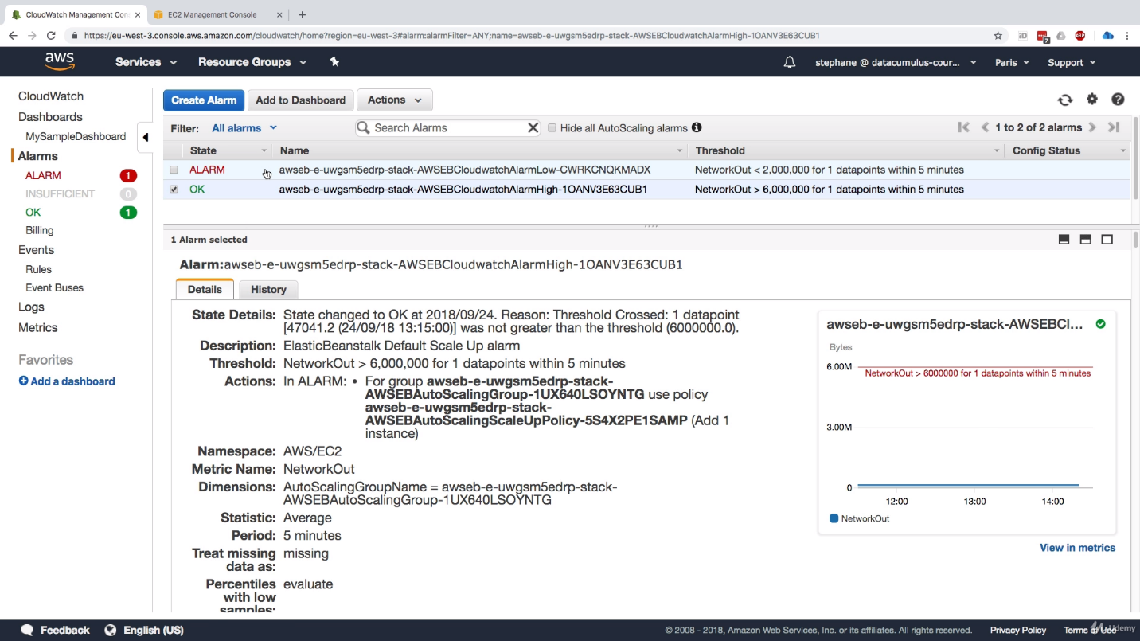

Below SS is for manual creation of Alarm for EC2 instances. We have chosen 3 datapoints and 5 minute period so this alarm will work when networkIn will cross limit (100 MB) for 15 min (3x5).

Here once we have multiple datapoints it will look for overall time period like if coming traffic for all 3 instances, is above 100 MB for 15 min then ALARM will work.

**CloudWatch Logs:**

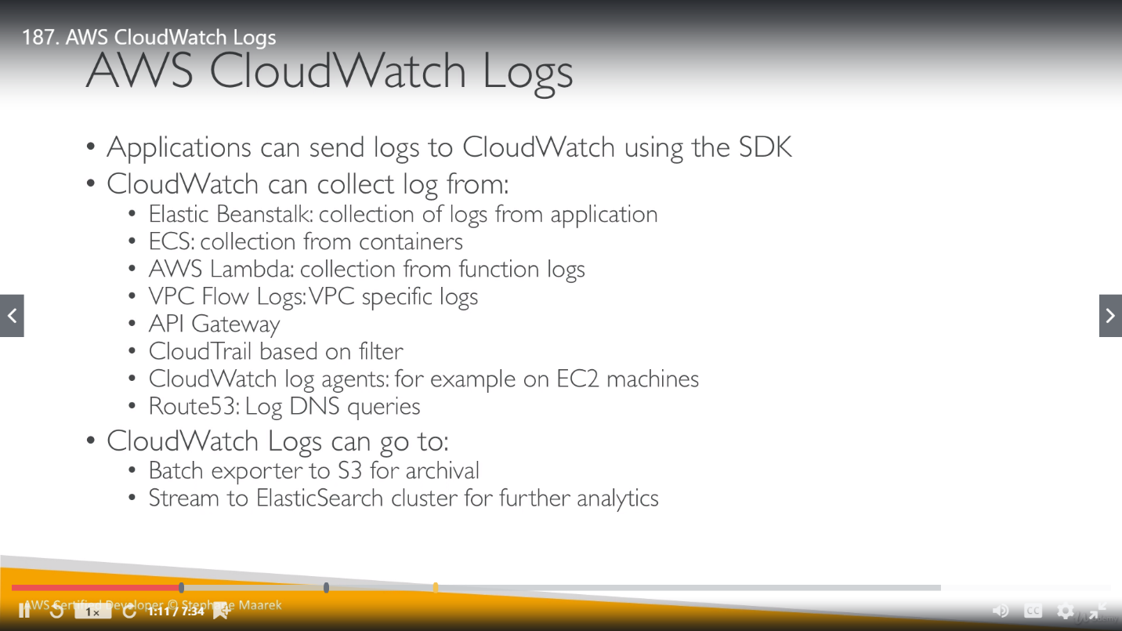

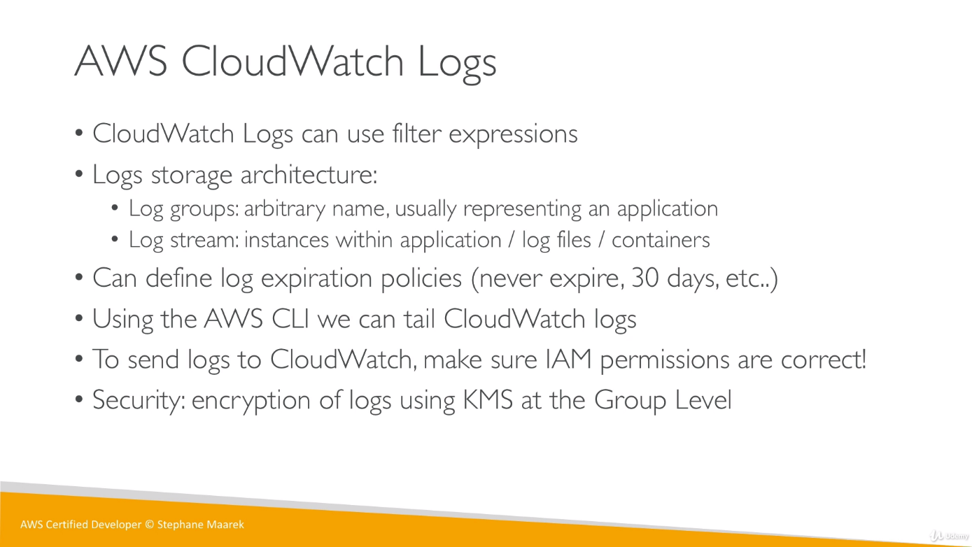

Once we check for logs, we can see there is already some logs which was generated for our build process in earlier topic.

We have different actions as Retention setting, which define when these logs will be expired. We can choose between many options. There is an option as “never expire” to never delete them.

We have an action for export/archive the logs into S3 bucket.

**CloudWatch logs for EC2 instances:**

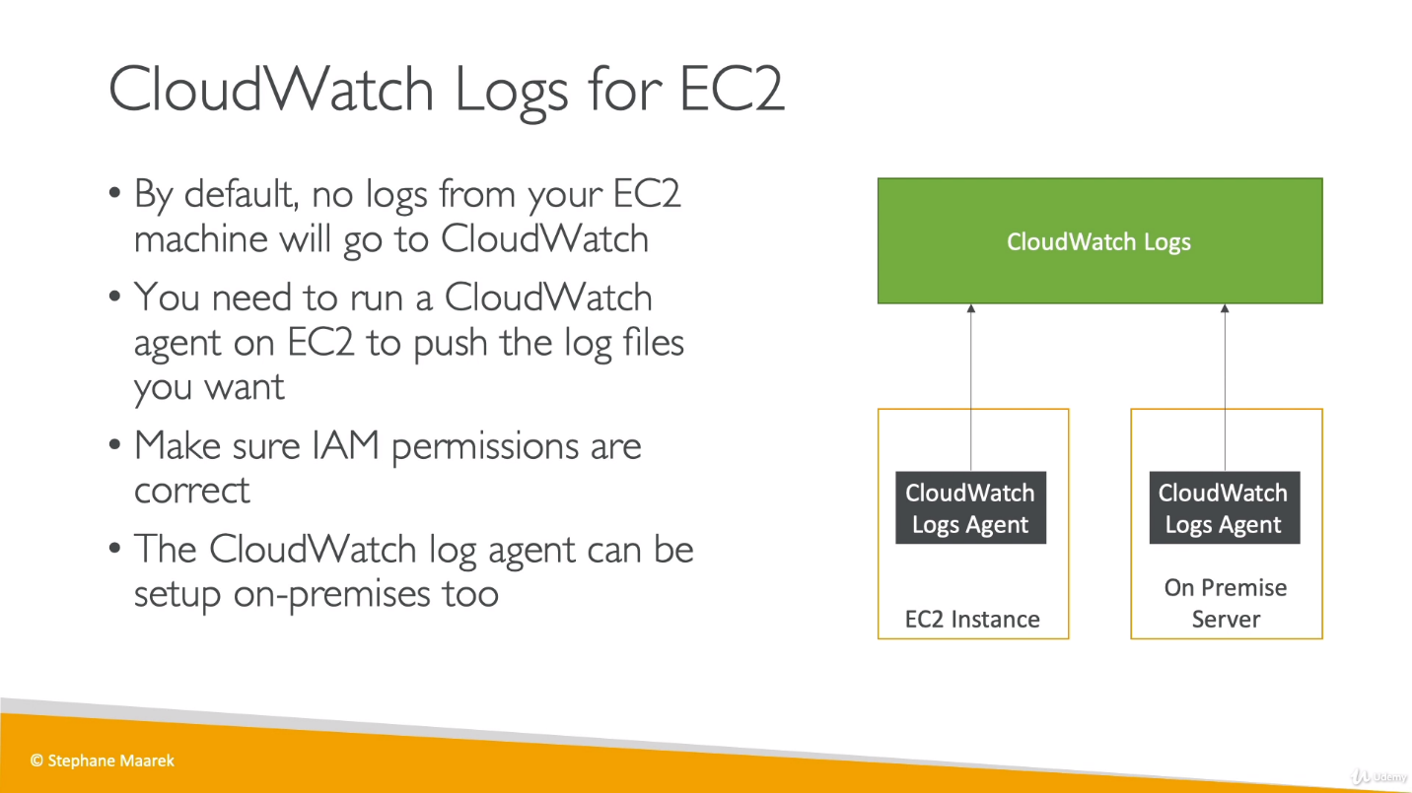

There are 2 agents, logs agent and Unified Agent. We just need to remember; log agent is old version and Unified Agent is newer one with additional features. No need to remember difference.

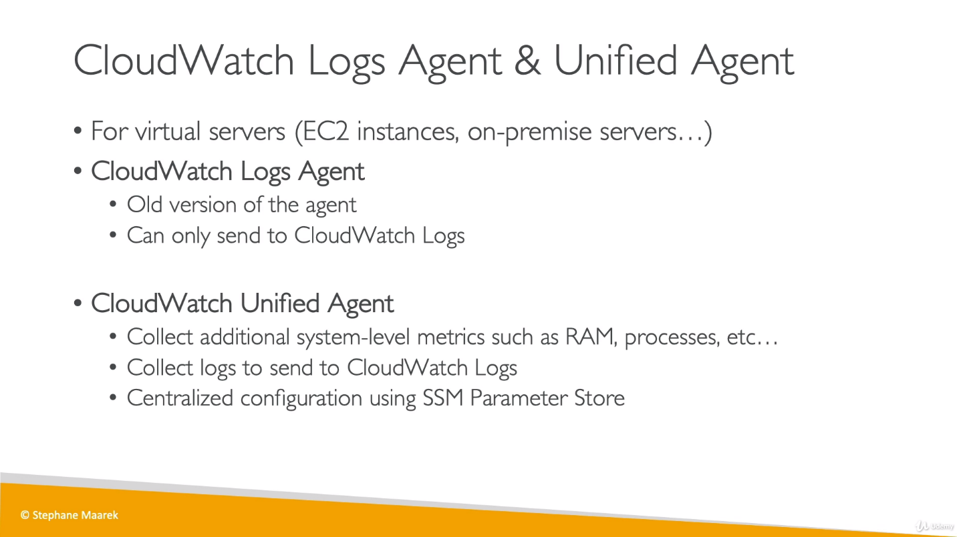

CloudWatch logs can use the **metric filters.**

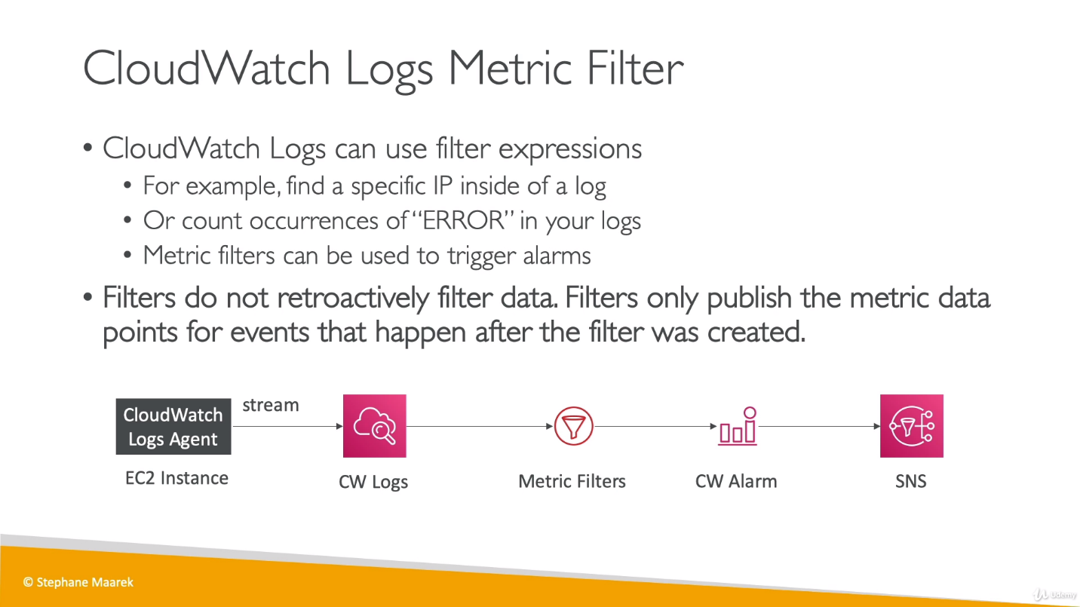

While creating a Metric Filter we need to provide a Pattern which is sometime complicated, and its syntax can be find out from documentation.

It will show only data that will come after creation of Metric Filter. It will not show the older data.

**CloudWatch Events:**

Events works on rules. We have 2 options to create event rules : Event Pattern, Schedule.

**Schedule:** We can schedule a job/batch for CloudWatch Events.

**Event Pattern:** We can also define rules like if something mentioned in rule is happening on a service, trigger an event. We have preexisted service like CodePipeline, mean we can setup a rule on this service.

**Event Pattern ex**: we can setup a role for CodePipeline stage changes so whenever a stage for this pipeline changes, trigger an event (like lambda function, SNS etc.) . We can set a topic for this stage change in Targets while creating this event.

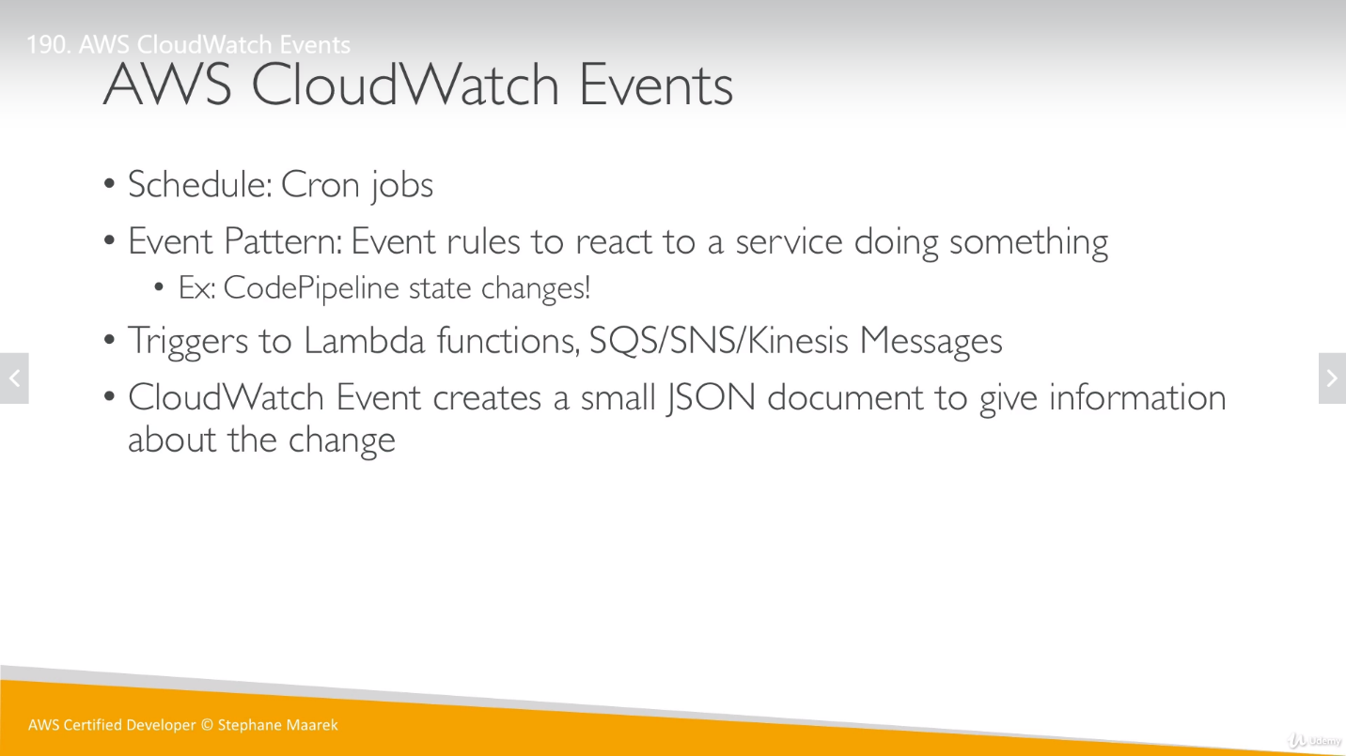

We have auto created rules which was created by AWS CodeCommit for the repository that we created, and they will trigger an SNS topic.

**Amazon EventBridge:**

EventBridge is advance of CloudWatch Events. Whenever we use Events, “Default Event Bus” is used. EventBridge use multiple buses. Ex:

1. Partner event Bus, this bus is to receive events from external SAAS services or applications.
2. Custom event Bus, for our own application.

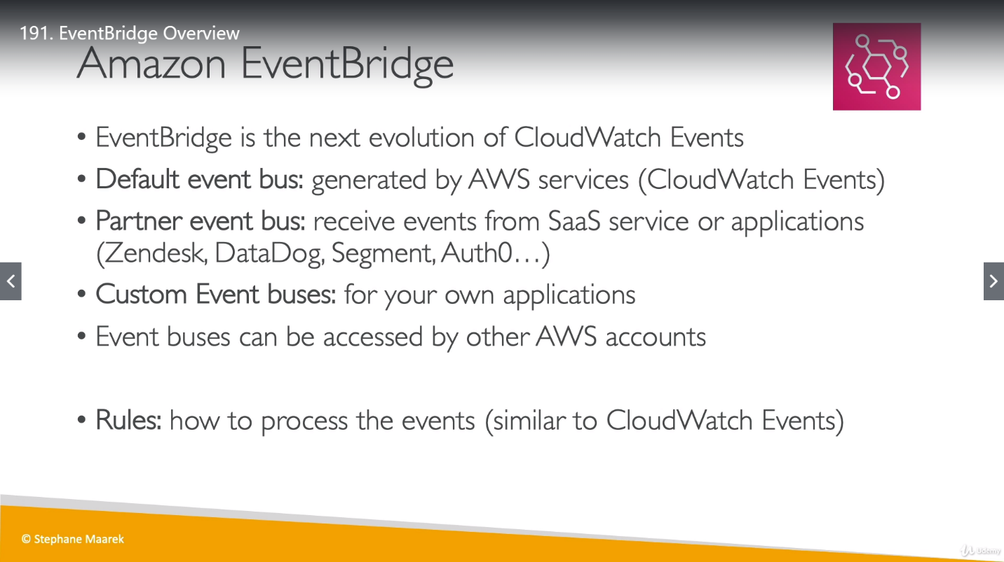

Schema: How the data is structured.

EventBridge has capability to analyze the events in the Bus and infer(guess) the schema from it.

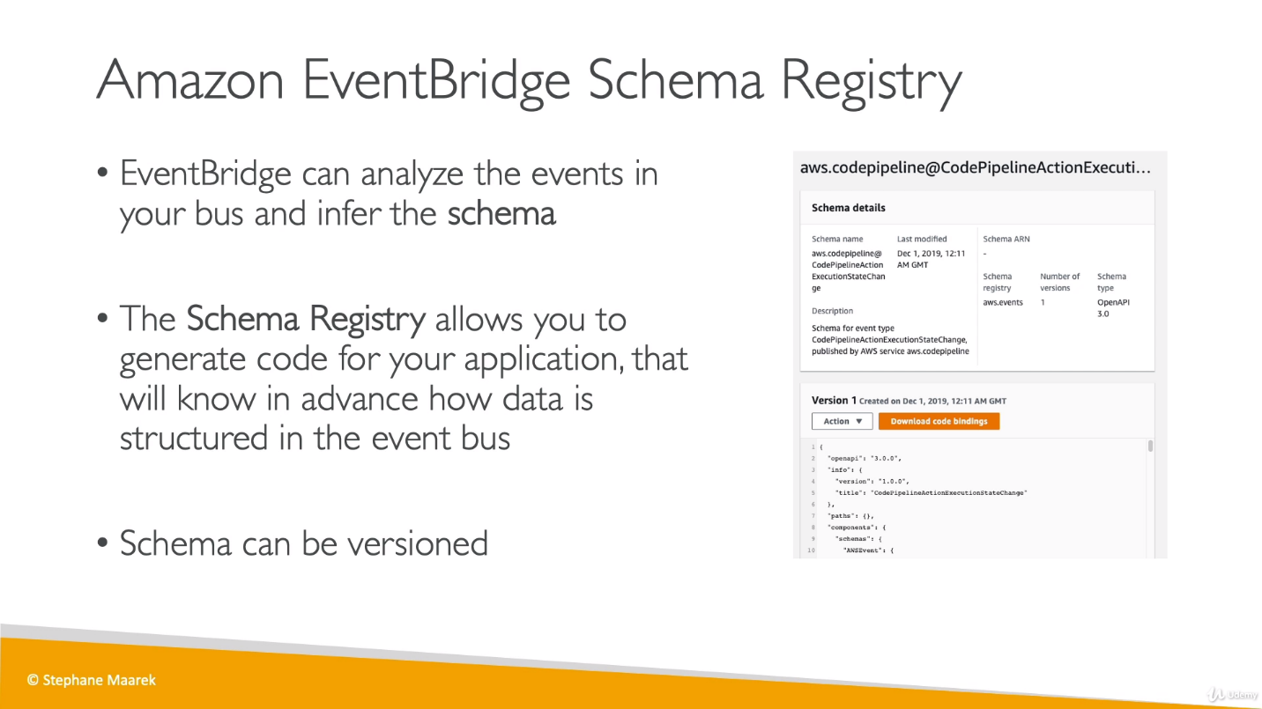

**Difference between CloudWatch Event and Amazon EventBridge:**

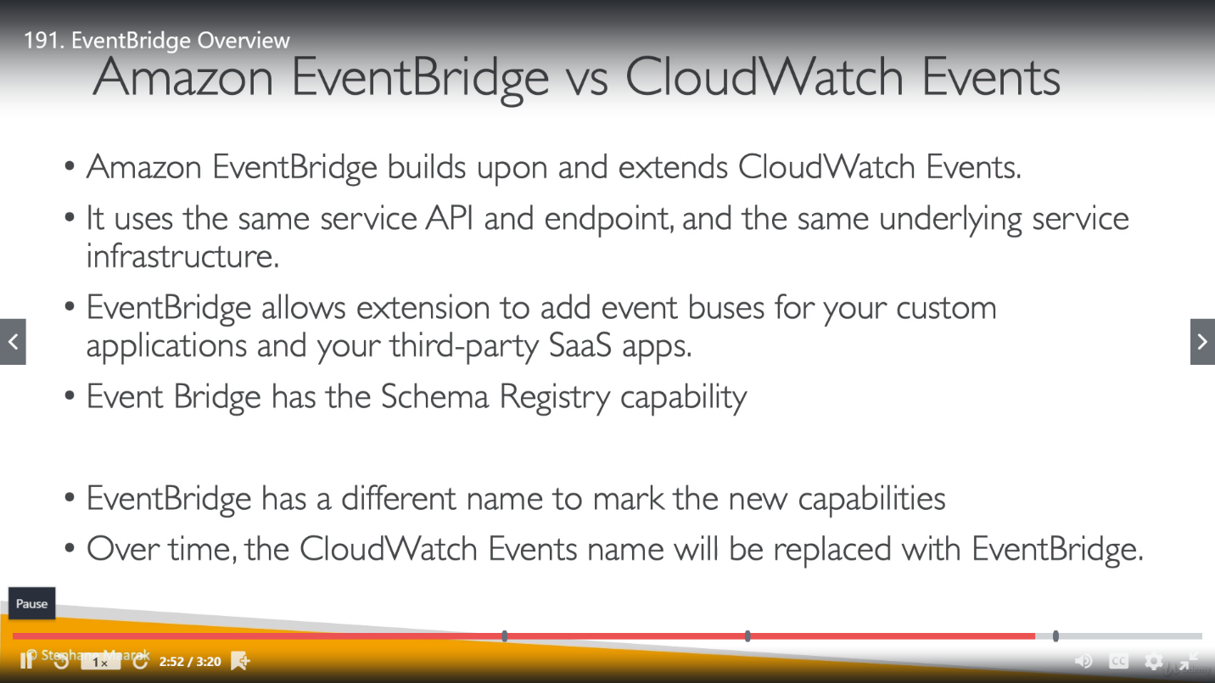

As CloudWatch Events and Amazon EventBridge are built on same infrastructure, we can see that same default rule are available in EventBridge as well.

**X-Ray: **imp\*\***

We get pictorial representation to get a clear picture of what is happening or what has happened to a service.

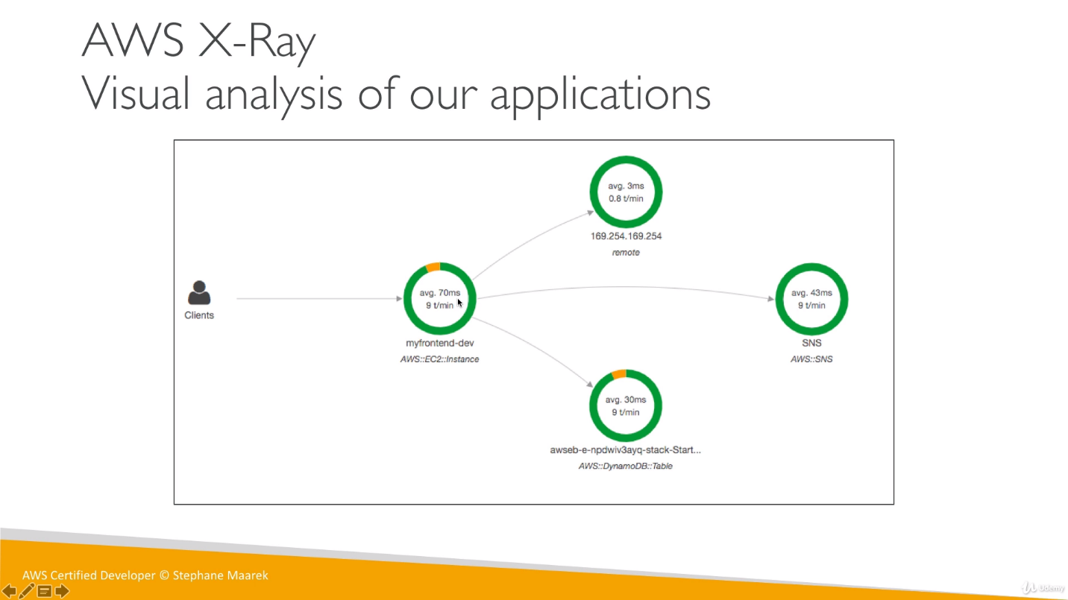

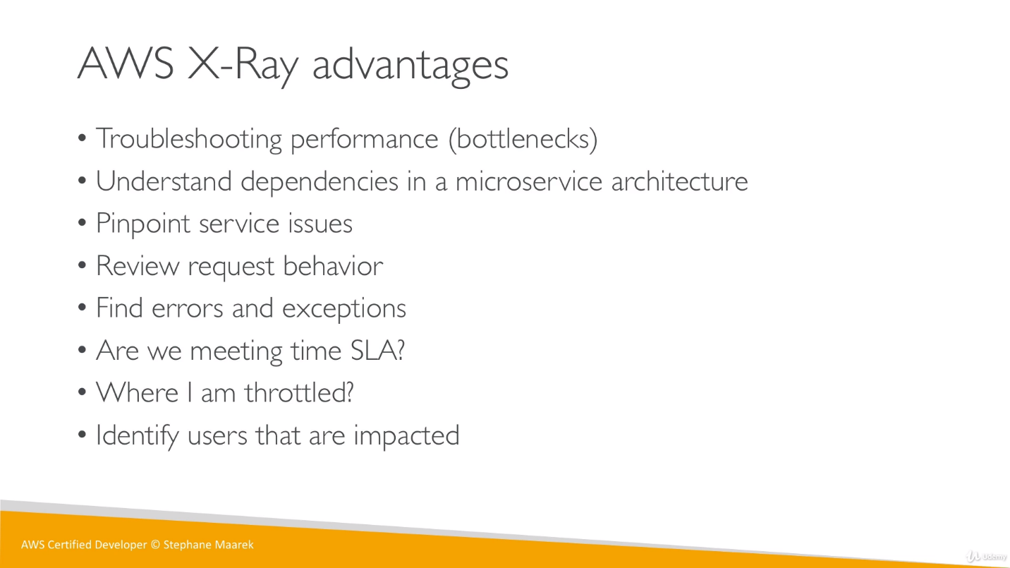

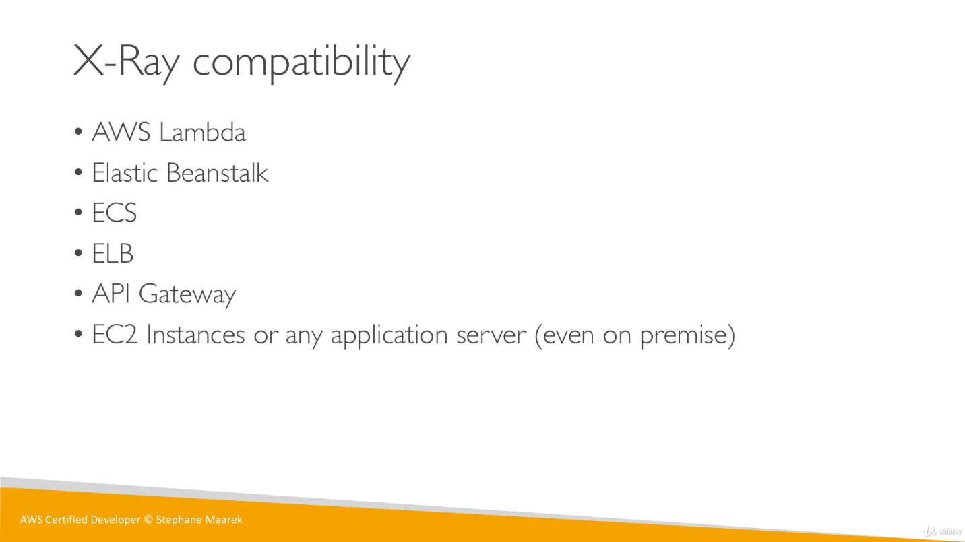

X-Ray can be used of tracing purpose, we can trace any request that was made for any service. Each interaction with any component/service will have its own trace. We can add annotations in trace to get additional information.

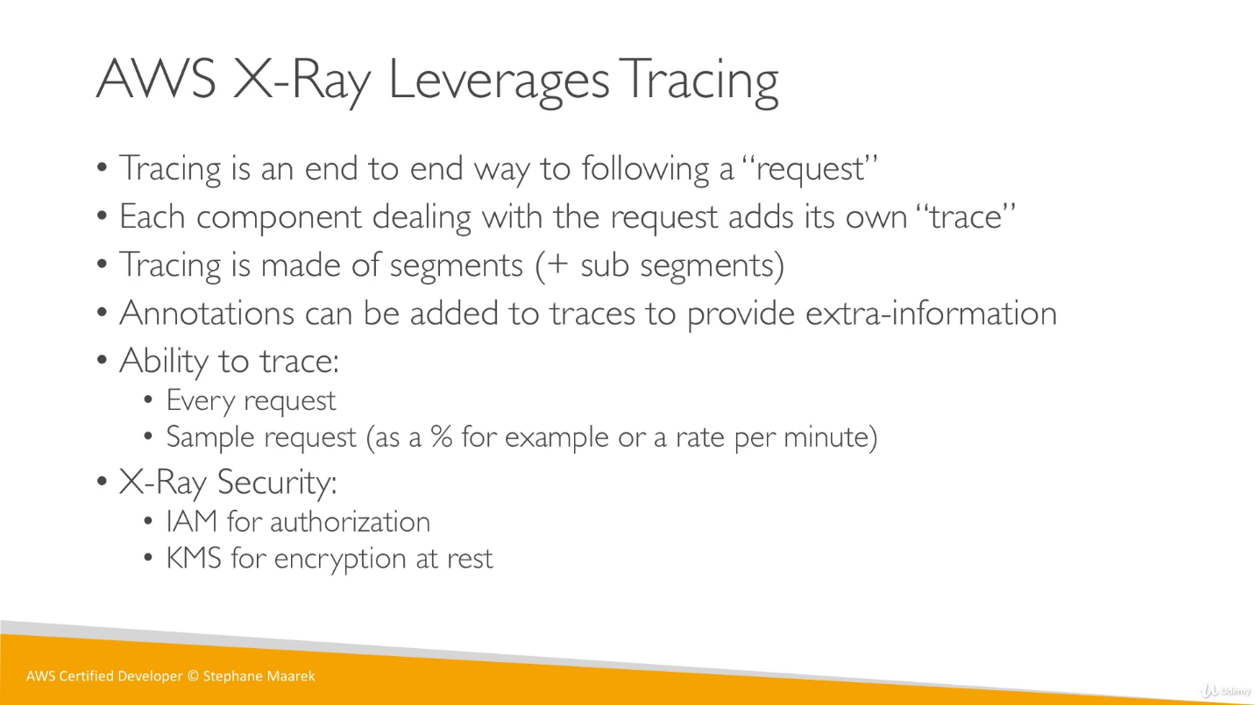

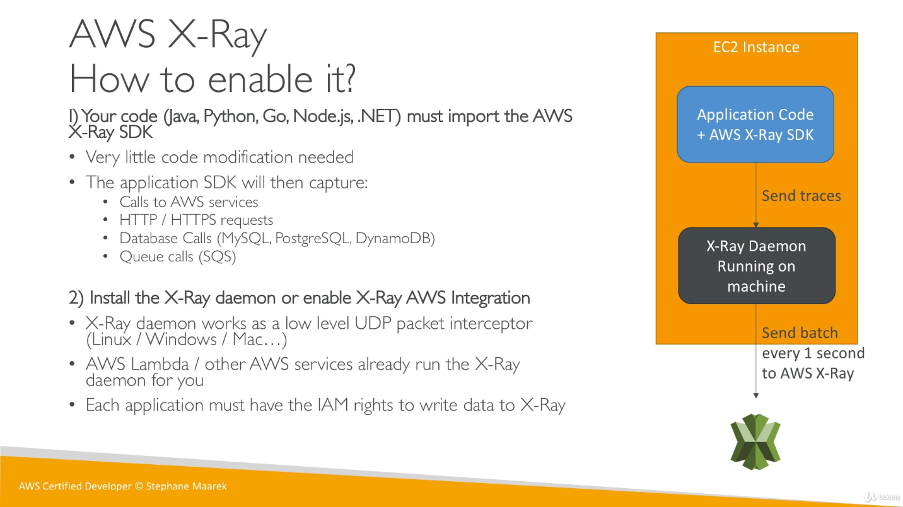

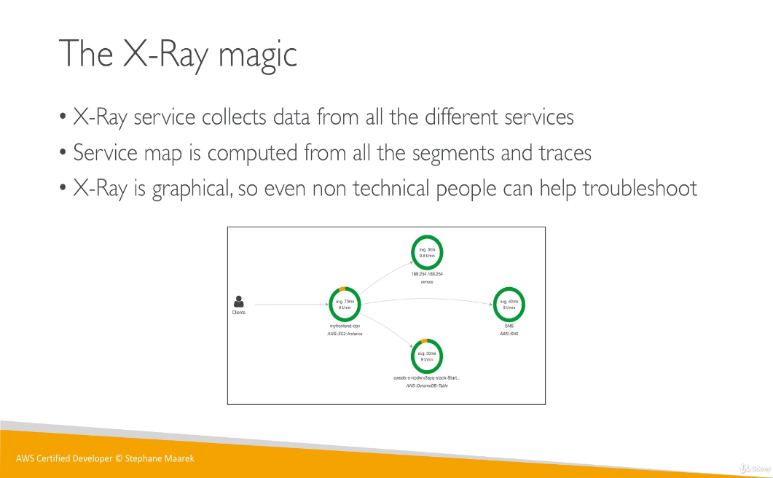

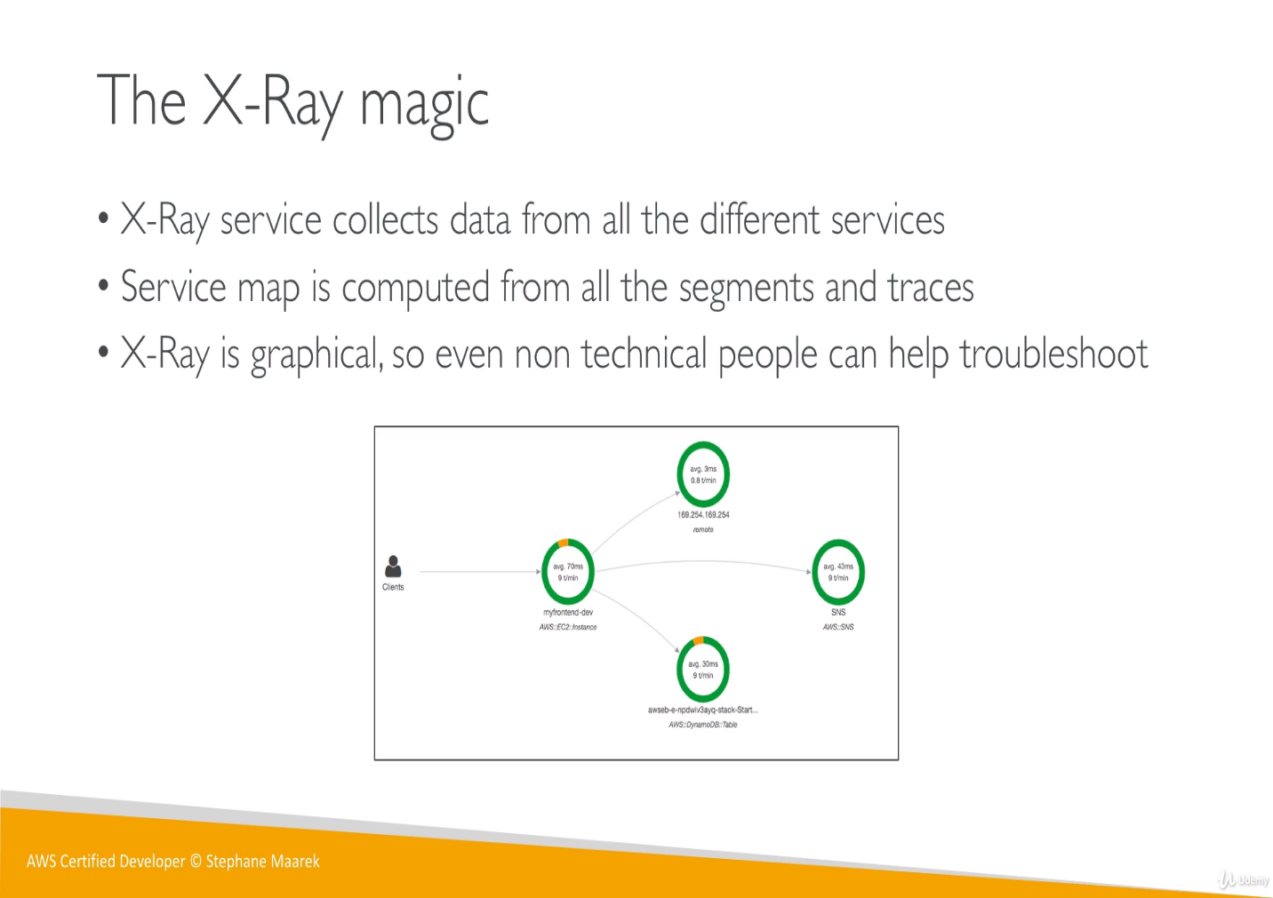

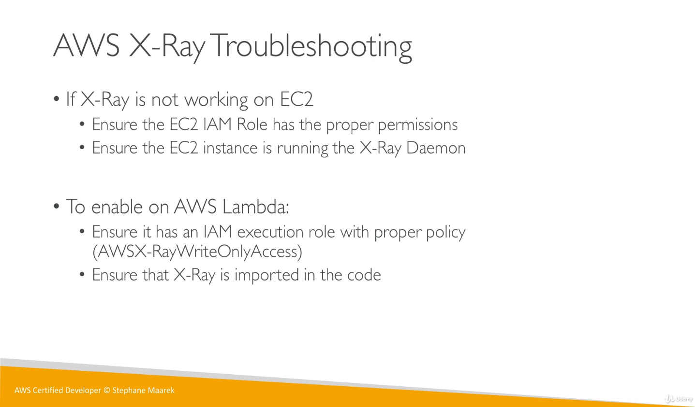

For AWS Lambda and for custom applications, we have to modify our code.

For custom applications, we have to modify our code to use SDK (modifications are different based on application language), and then the X-Ray Daemon should run.

The AWS X-Ray SDK does not send trace data directly to AWS X-Ray. To avoid calling the service every time our application serves a request, the SDK sends the trace data to a daemon, which collects segments for multiple requests and uploads them in batches.

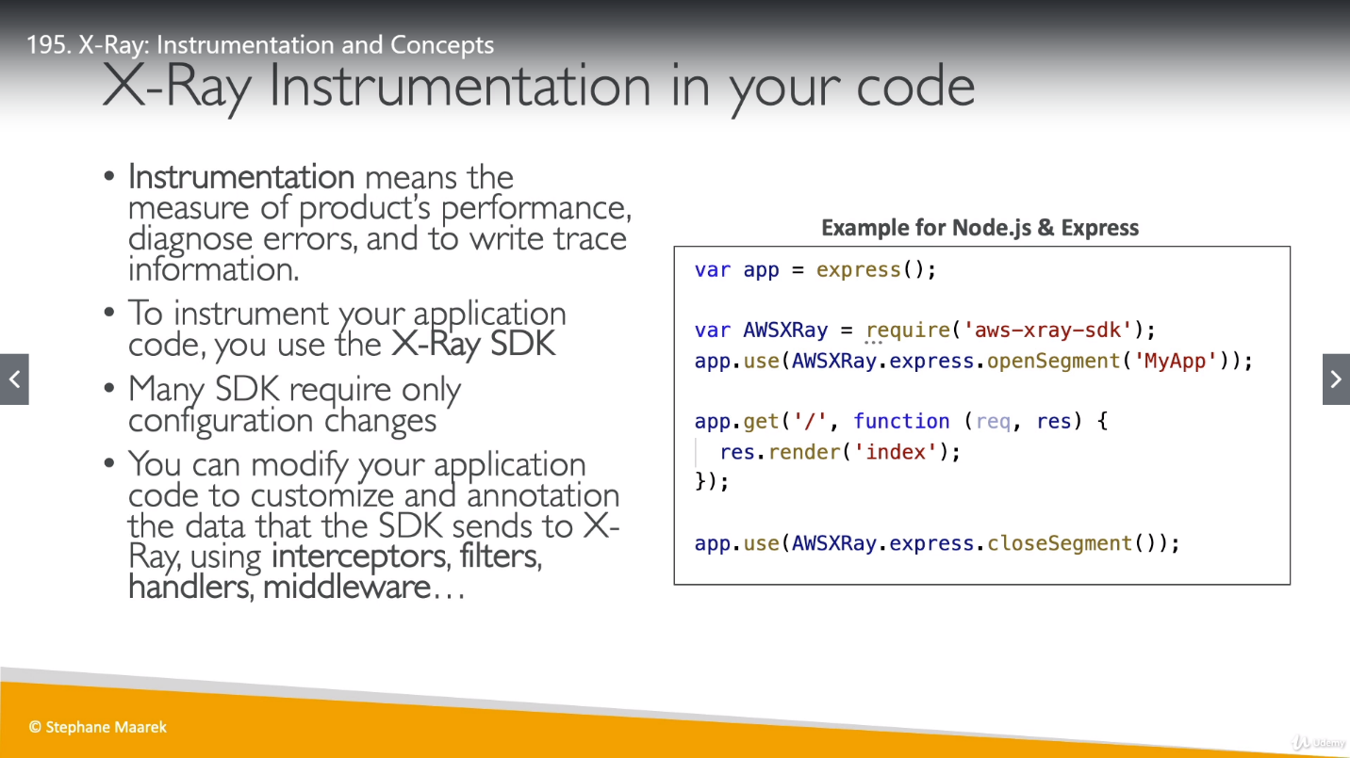

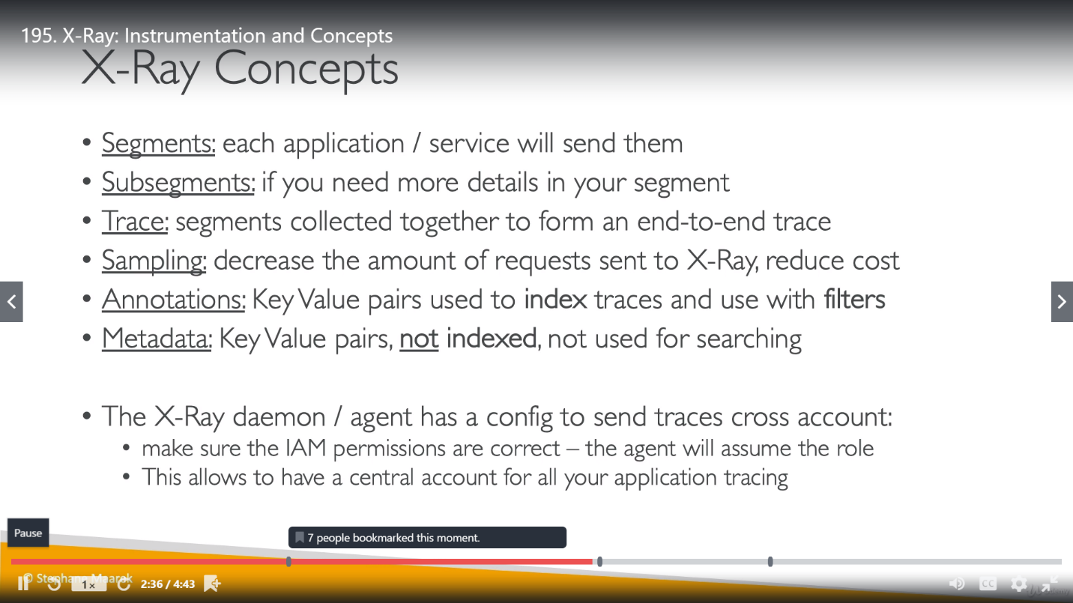

We can use only annotations for searching because they are indexed but we can’t use metadata for searching because they are not indexed.

**X-Ray sampling Rules:**

We can modify the default rule's reservoir and rate.

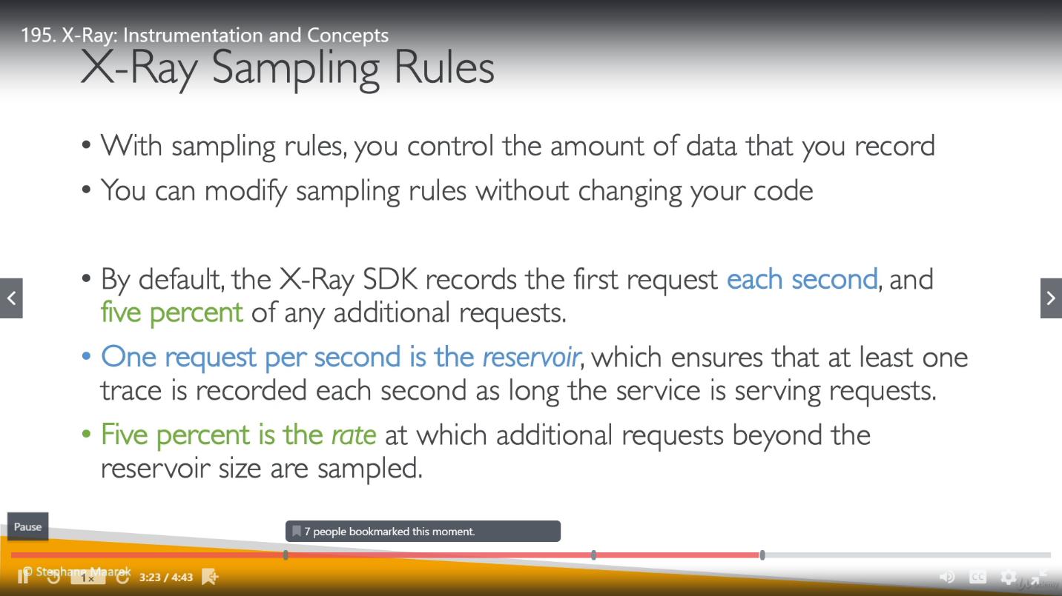

**Reservoir:** request/sec

**Rate:** once reservoir is exhausts, what percentage of requests will be served.

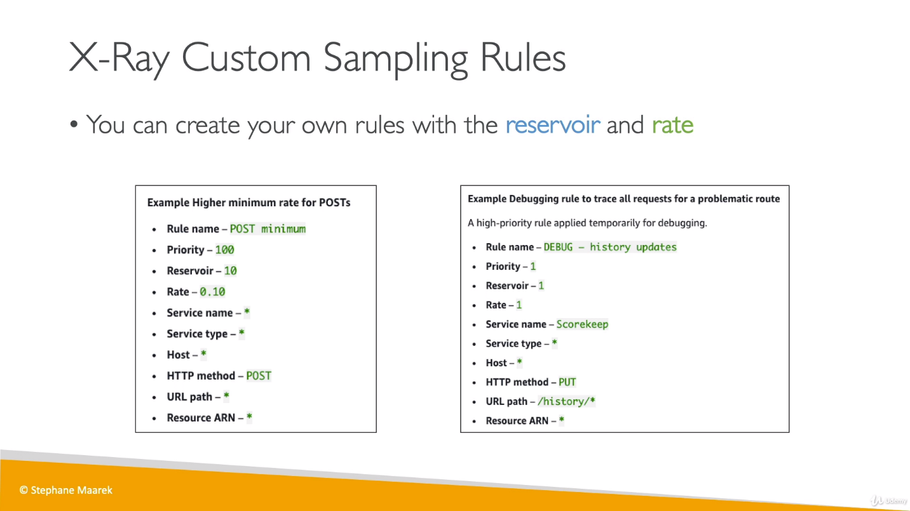

In first example, 10 req/sec will be sent to X-Ray, once there are more requests then 10% of those will be served (mentioned by Rate 0.10).

In debugging example, as Reservoir and Rate is 1 (which mean 100%)so all request will be served, because we don’t want to lose any Traces. we have to pay more here but its good to use this data for debugging purpose to know what is happening for services.

Once we change the X-ray rules, we not need to restart the service, automatically Daemon knows how to get these sampling rules and correctly send the right amount of data in X-ray service.

**imp**

We get data in X-Ray from number of different applications which are having running X-Ray Daemon. Once we sample X-Ray data will change according to the modification that we did know for sampling.

